1. Create a Bugzilla account using your college or personal email, then log in and take a screenshot of your Bugzilla dashboard after successful login.

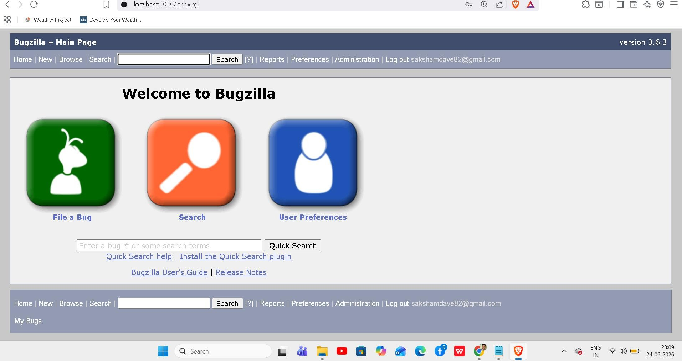
ANS:-

2.Pick any mobile app you use daily (such as Instagram, Zomato, or Paytm) and identify a real or imagined bug you have experienced — log this bug in Bugzilla with a clear summary, detailed steps to reproduce, expected vs actual result, and attach a screenshot or mock image showing the issue.

Ans:
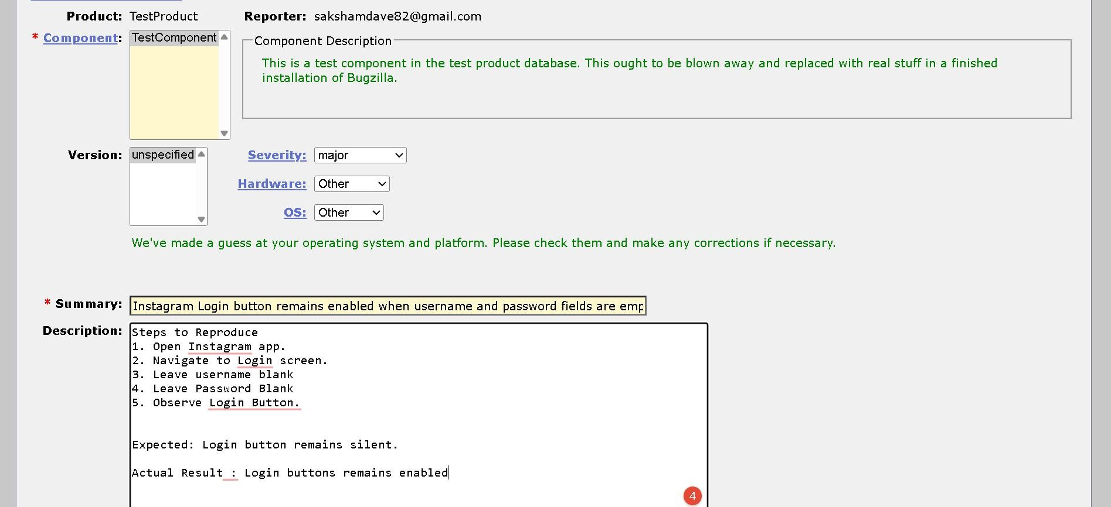
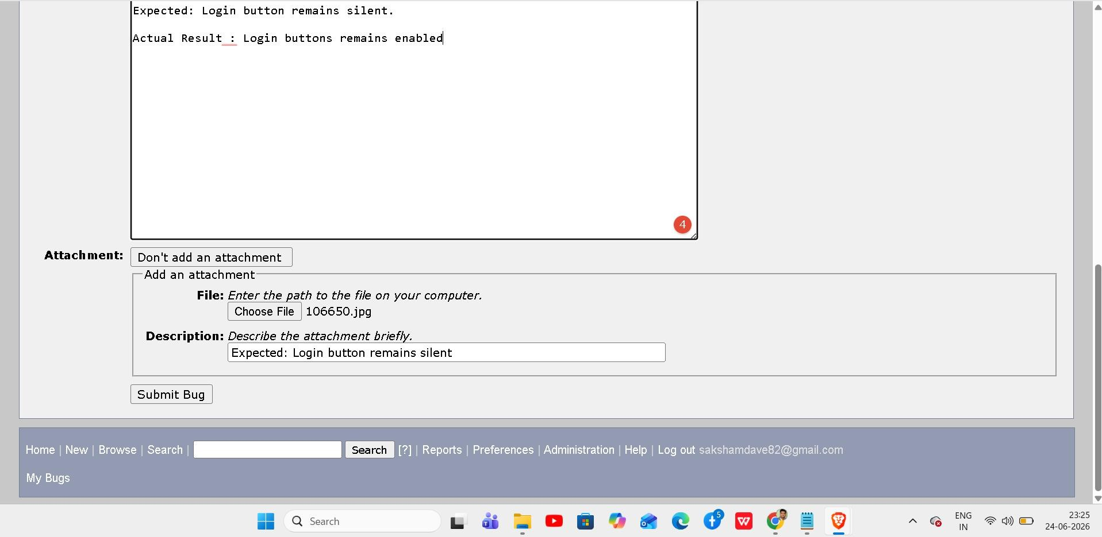

3. Log two more defects in Bugzilla for different apps (for example, a payment failure in PhonePe or a wrong item added in Flipkart cart), making sure to select appropriate Severity and Priority for each defect and fill out the Module and Build/Version fields.
Ans:
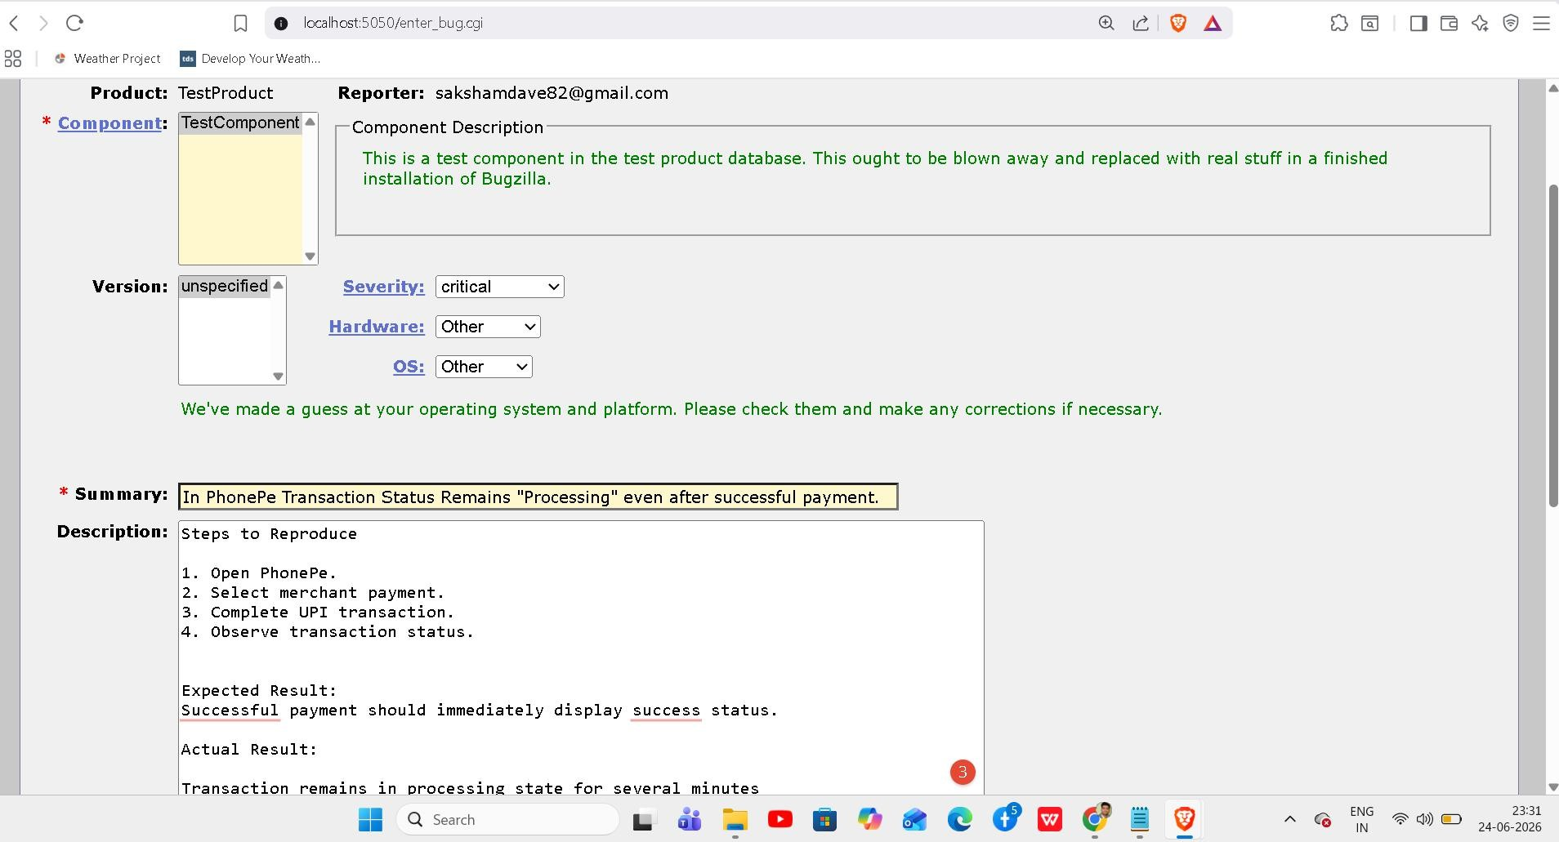

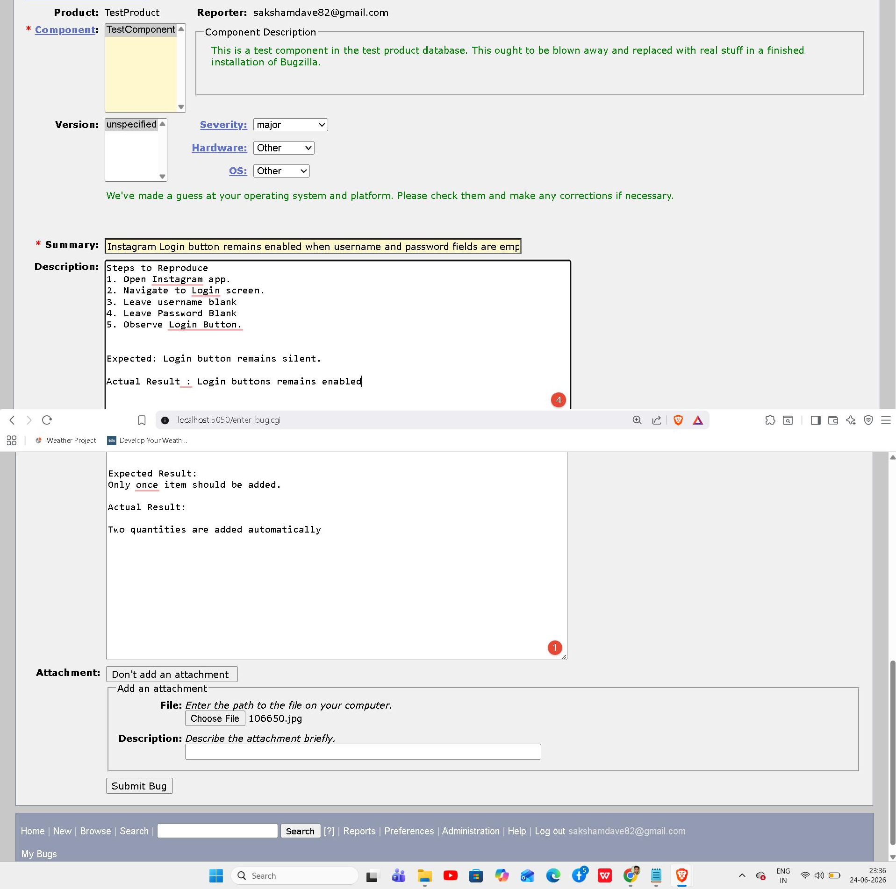

4. Update the status of one of your logged defects in Bugzilla from 'New' to 'Assigned', then to 'Fixed', 'Retest', and finally 'Closed', adding a brief comment at each stage describing what happened.<br><br><em><strong>Hint:</strong> Use the 'Add Comment' box in Bugzilla to note what action was taken at each step.</em>.

Ans: New → Assigned

Comment: Issue reviewed and assigned to development team for investigation. Assigned → Fixed
Comment: Root cause identified and code changes implemented. Issue marked as fixed.

Fixed → Retest

Comment: Fix deployed to testing environment and ready for QA verification. Retest → Closed
Comment: Issue verified successfully. Expected result achieved. Defect closed.

5. Use Bugzilla's search and filter features to find all defects you have logged that are currently not 'Closed', and take a screenshot showing the filtered results.<br><br><em><strong>Hint:</strong> Try filtering by your user ID and by defect status.</em>

Ans:
